ST. ERVAN PARISH COUNCIL
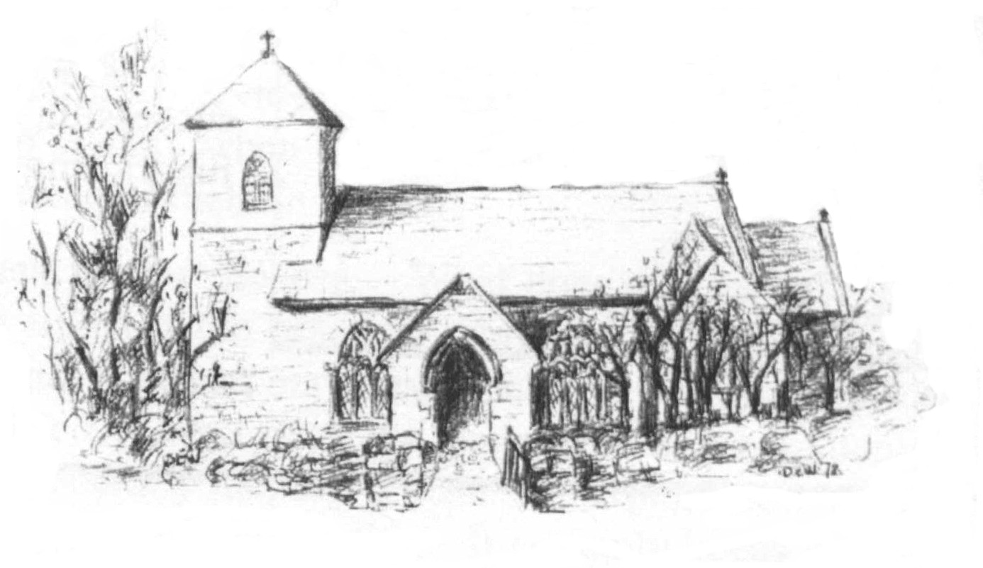
Jacqui Peskett
Parish Clerk
Tel 07835 937261
Email stervanpc@outlook.com

St Ervan Parish Council Meeting Minutes – Tuesday 2nd January 2024 held at St Ervan Village Hall commencing at 7pm.

Present: Cllrs R Biddick (Chair), J Eustice, M Biddick, R Kent, L Wood, L Clarke.

Apologies: Cllrs Skinner, The Clerk & Cornwall Councillor Stephen Rushworth

Members of the Public 0

45 Declarations of interest: None.

46 Public Participation: None.

47 Cornwall Councillor Report: Not present

48 St Ervan Parish Council Meeting 7th November 2023 & Matters arising: It was proposed by Cllr Kent, seconded by Cllr M Biddick and resolved that the minutes of the ordinary meeting held on the above date and having been previously circulated, be accepted. All in favour, carried. No matters arising.

49 Planning Applications: To CONSIDER Planning Applications or any that may be received since the agenda was published:

Ref. No: PA23/07429
Demolition of disused piggery buildings and construction of 4 live/work units
The Old Piggeries Treginegar Farm St Merryn Padstow Cornwall PL28 8PT
Received: Tue 12 Sep 2023 | Validated: Tue 19 Dec 2023
It was proposed by Cllr M Biddick seconded by Cllr Eustace and resolved to SUPPORT the application.
All in favour, carried
Ref. No: PA23/09604
Construction of calf shed to support agricultural enterprise
Eddystone Farm Barns St Ervan Wadebridge Cornwall PL27 7SJ
Received: Sat 25 Nov 2023 | Validated: Fri 15 Dec 2023

It was proposed by Cllr Clarke, seconded by Cllr M Biddick and resolved to SUPPORT the application.
All in favour, carried

50 Correspondence: To RECEIVE the Police report (previously circulated) – noted

51 Highways to CONSIDER any issues that may have arisen and RESOLVE appropriate action:
White lines at Rumford Cross Roads.
Potholes at Dolgey Post.
The Clerk to raise the issue with Highways.

52 Items for information: To CONSIDER, APPROVE and RESLOVE a course of action if appropriate: Painting of Defibrilltor cabinet deferred to March meeting.

53 Finance
Payments:
Clerk’s Remuneration 2 months | £266.74
Clerk’s Expenses 2 months | £51.25
HMRC/PAYE | (In credit)
St Ervan Village Hall (Hire for meetings) | £85.00
Andy Hoskin (Grass Cutting) | £ £1000.00

Income:
Interest | £ 10.33

Balances as at time of setting the Agenda.
Treasurers Account | £ 58.95
Business Instant Access Account | £4,669.84
It was proposed by Cllr Clarke., seconded by Cllr Wood and resolved that these are accepted and paid, all in favour carried.

54 Items for the March meeting: No new items.

The Chairman closed the meeting at 7.30pm

Date of next scheduled Meeting Tuesday 5th March 2024 @ 7pm.

Signed………………………………………….

